**Software Engineering**

**Home Assignment – 1**

1. Summarize Perspective, Evolutionary, Specialized and Unified Process Models

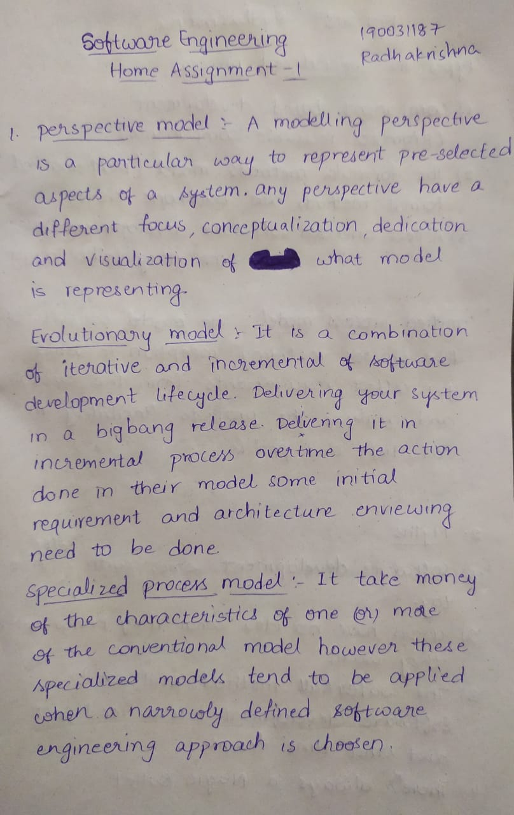

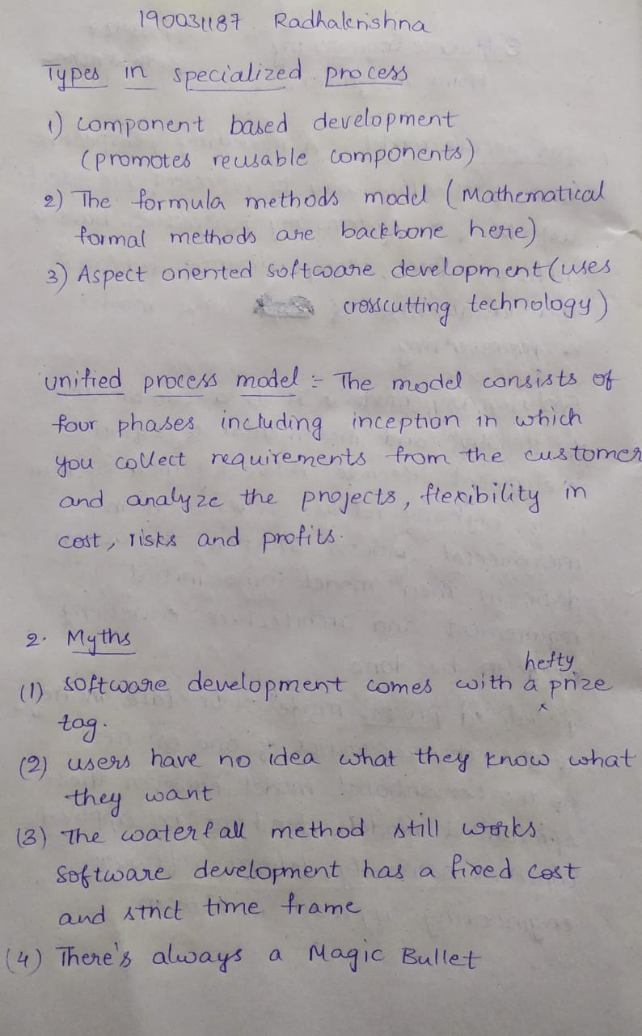

1. Discuss Various myths and realities in software engineering



